Normal LED Circuit
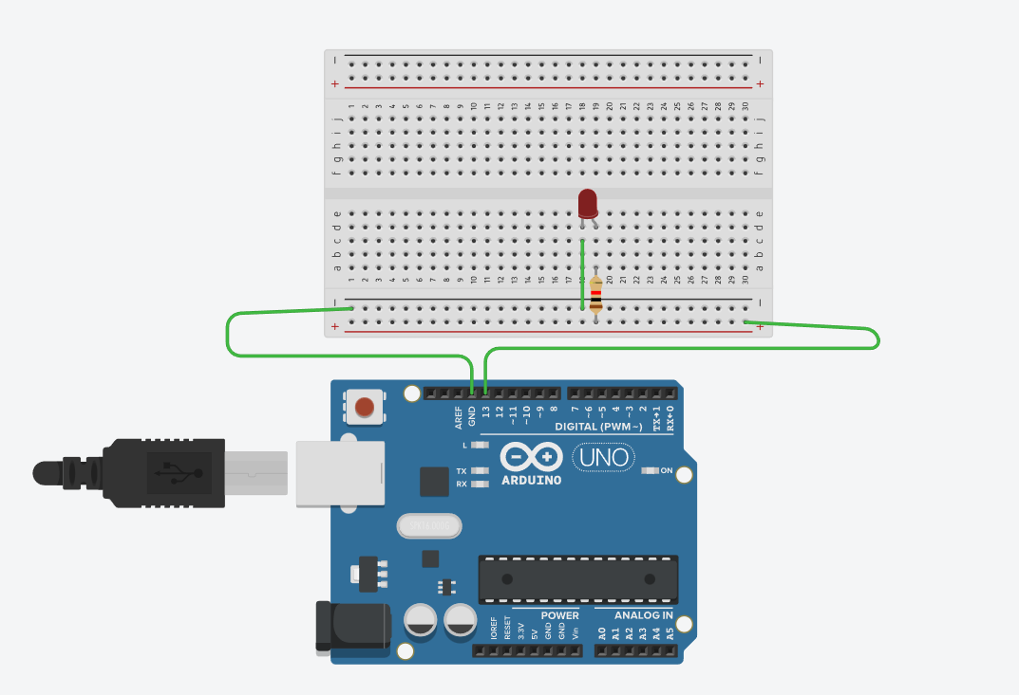
Traffic lights
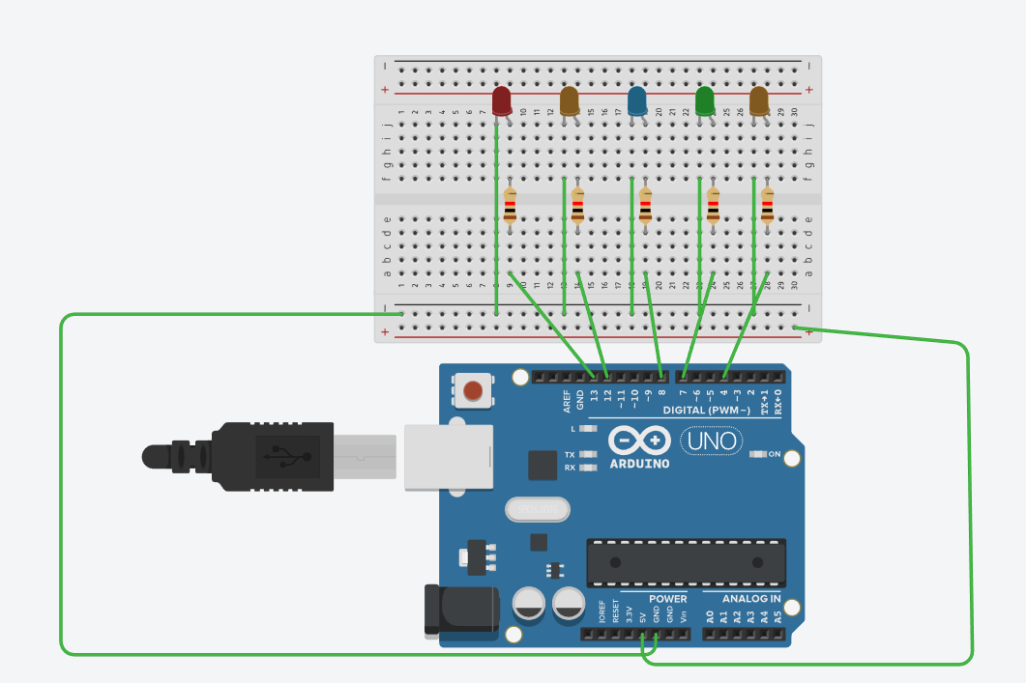
Code:
int led1 = 13;
int led2 = 12;
int led3 = 8;
int led4 = 7;
int led5 = 4;

void setup() {
pinMode(led1, OUTPUT);
pinMode(led2, OUTPUT);
pinMode(led3, OUTPUT);
pinMode(led4, OUTPUT);
pinMode(led5, OUTPUT);
}

void loop() {

digitalWrite(led1, HIGH);
delay(200);
digitalWrite(led1, LOW);
delay(100);

digitalWrite(led2, HIGH);
delay(100);
digitalWrite(led2, LOW);
delay(100);

digitalWrite(led3, HIGH);
delay(100);
digitalWrite(led3, LOW);
delay(100);

digitalWrite(led4, HIGH);
delay(100);
digitalWrite(led4, LOW);
delay(100);

digitalWrite(led5, HIGH);
delay(100);
digitalWrite(led5, LOW);
delay(100);
}

Button circuit
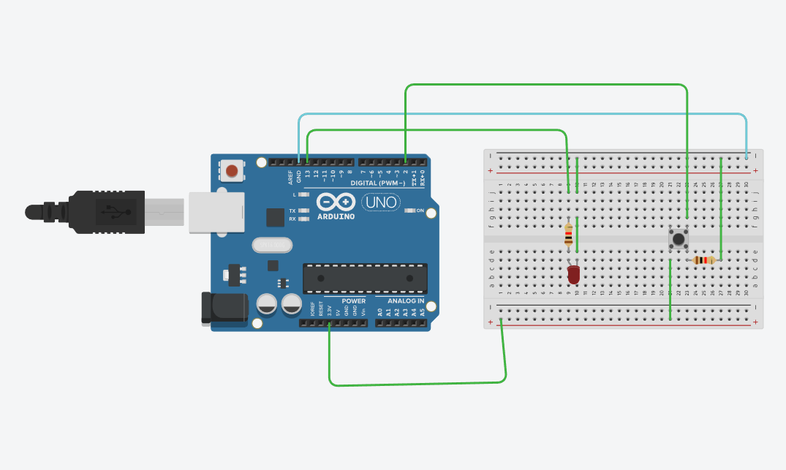

Code:

int led = 13;
int pushButton = 2;

void setup() {
Serial.begin(9600);
pinMode(pushButton, INPUT); // or INPUT_PULLUP if you remove the resistor
pinMode(led, OUTPUT);
}

void loop() {
int buttonState = digitalRead(pushButton);

Serial.println(buttonState);

if (buttonState == HIGH) {
digitalWrite(led, HIGH);
} else {
digitalWrite(led, LOW);
}

delay(100);
}

Photoresistor

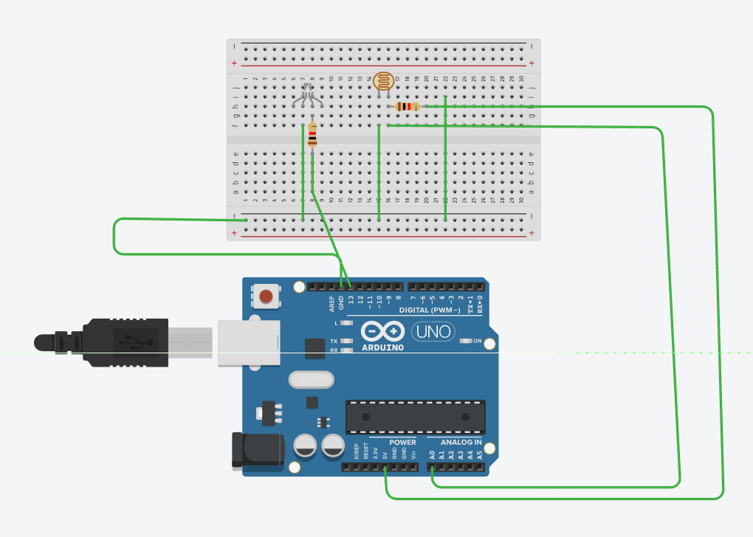
Code:

const int ldrPin = A0; // LDR connected to A0
const int ledPin = 13; // LED on pin 13
int threshold = 500; // Adjust this depending on your light level

void setup() {
pinMode(ledPin, OUTPUT);
Serial.begin(9600);
}

void loop() {
int val = analogRead(ldrPin); // read LDR value

Serial.println(val); // print to Serial Monitor

if (val < threshold) { // darker = smaller value
digitalWrite(ledPin, HIGH); // LED ON in dark
} else {
digitalWrite(ledPin, LOW); // LED OFF in light
}

delay(200);
}

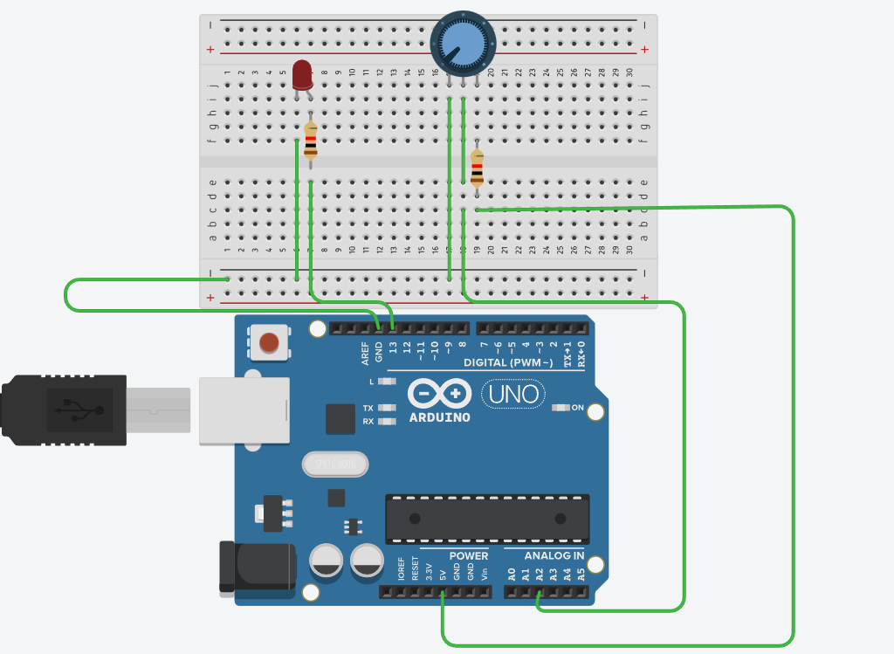Potentiometer

Code:
int potPin = A2; // Potentiometer middle pin
int ledPin = 13; // LED pin

void setup() {
Serial.begin(9600);
pinMode(ledPin, OUTPUT);
}

void loop() {

int potValue = analogRead(potPin); // Read potentiometer value (0–1023)

Serial.print("POT: ");
Serial.println(potValue);

// If potentiometer is turned above halfway (512)
if (potValue > 512) {
digitalWrite(ledPin, HIGH); // LED ON
} else {
digitalWrite(ledPin, LOW); // LED OFF
}

delay(100);
}

